# SYSTEM ANALYSIS

## Dataset Analysis

The dataset the project intends to use consists of 2000 data for each label initially among which 85% is divided into train data and remaining 15% as test data The data for each label are stored in the same folder and the name of the folder is same as the label for the data. The folder structure for the dataset is visualized below:

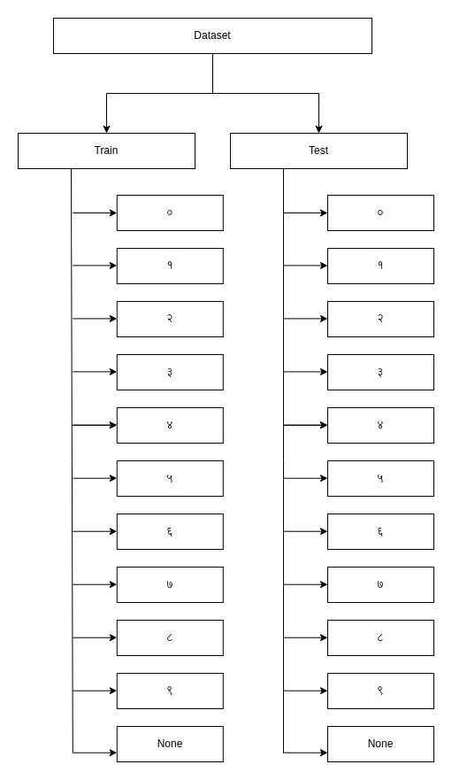

Figure 1 Folder Structure for dataset

Each image is of a fixed size i.e. 32 * 32 pixels. This makes it easy for the data preprocessing as it removes the overhead of resizing the images into a same size. The images are black and white hence have only one color channel.

# SYSTEM DESIGN

## Model Architecture

The project is based upon the Multilayer Perceptron architecture. The input layer is of size 1024, this is due to the fact that each image size is 32 * 32 pixels and they are stacked into a single dimension resulting in a 1024 inputs.

A simple representation of the model architecture is shown below:

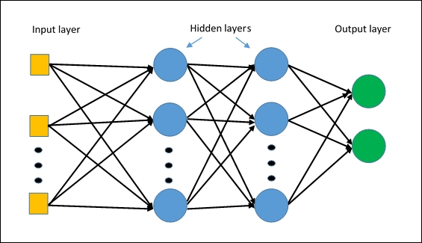

Figure 2 Multilayer Perceptron

The model consists of the 3 types of layers:

1. **Input Layer**

The input layer of a Artificial Neural Network is the layer responsible for bringing in the data from outside to the network. The shape of the input layer depends on the size of the input. In the case of this project, the input layer will consist of 32 * 32 image stacked into a single vector.

1. **Hidden layer**

The hidden layers are the layers that are stacked between input and the output layer of the network. These layer don’t interract with the external environments of the network. They take inputs from input layers or other hidden layers and the outputs from these layers are utilized as input in output layer or the hidden layers.

For this project the size and the number of the hidden layer will be determined based on the performance of the model but the model will consist more than 2 hidden layers.

1. **Output Layer**

The output layer is the layer in which the network outputs its predictions. For this project the output layer will output 11 possible outcomes, 10 for the every Nepali digits and 1 for non-digit character recognition.